**Lab Practical #03:**

Study of different types of network cables & connectors and crimping a LAN.

**Practical Assignment #03:**

1. List various networks cable. Also, write short description.
2. Difference between guided and unguided media.
3. Give cross-wired cable and straight through cable diagram (Color Code wise).

## List various networks cable and connectors. Also, write short description.

**a) Twisted Pair Cable (UTP/STP)**

* **Construction:**
  + Made of two insulated copper wires twisted together in a spiral pattern.
  + The twisting reduces crosstalk (interference from adjacent pairs) and electromagnetic induction.
* **Features:**
  + Lightweight, cheap, and easy to install.
  + Frequency range: 0–3.5 KHz.
  + Noise reduction improves with more twists per foot.
* **Types:**
  + **UTP (Unshielded Twisted Pair):**
    - Common in telecommunication and Ethernet LANs.
    - Inexpensive but has weak immunity to noise.
    - Used for telephone lines and high-speed LAN connections (Cat 1–5).
  + **STP (Shielded Twisted Pair):**
    - Has an extra shielding mesh to allow higher transmission rates and reduced noise.
    - More expensive than UTP; used for exterior/outdoor networking**.**
* **Usage:** Telephone lines, LANs, data & voice transmission.
* **Diagram:**

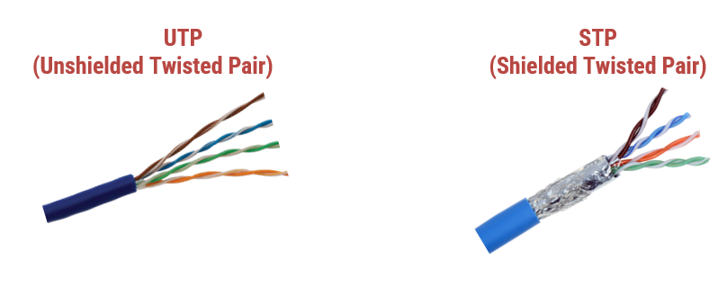

### ****b) Coaxial Cable:****

* **Construction:**
  + **Inner Conductor:** Solid copper core for data transmission.
  + **Insulating Layer:** Dielectric material separating conductor and shield.
  + **Outer Conductor:** Braided shield for preventing **electromagnetic interference (EMI)**.
  + **Plastic Jacket:** Outer protective covering.
* **Features:**
  + Provides **better shielding** and **higher frequency** than twisted pair.
  + Supports **baseband transmission** (single high-speed signal) and **broadband transmission** (multiple signals).
* **Advantages:**
  + High-speed data transmission.
  + Better noise immunity.
  + Higher bandwidth than twisted pair.
* **Disadvantages:**
  + More expensive than twisted pair.
  + A fault can cause network failure.
* **Usage:** Cable TV, broadband internet, CCTV, long-distance telephone transmission.
* **Connector:** BNC (Bayonet Neill–Concelman).
* **Diagram:** 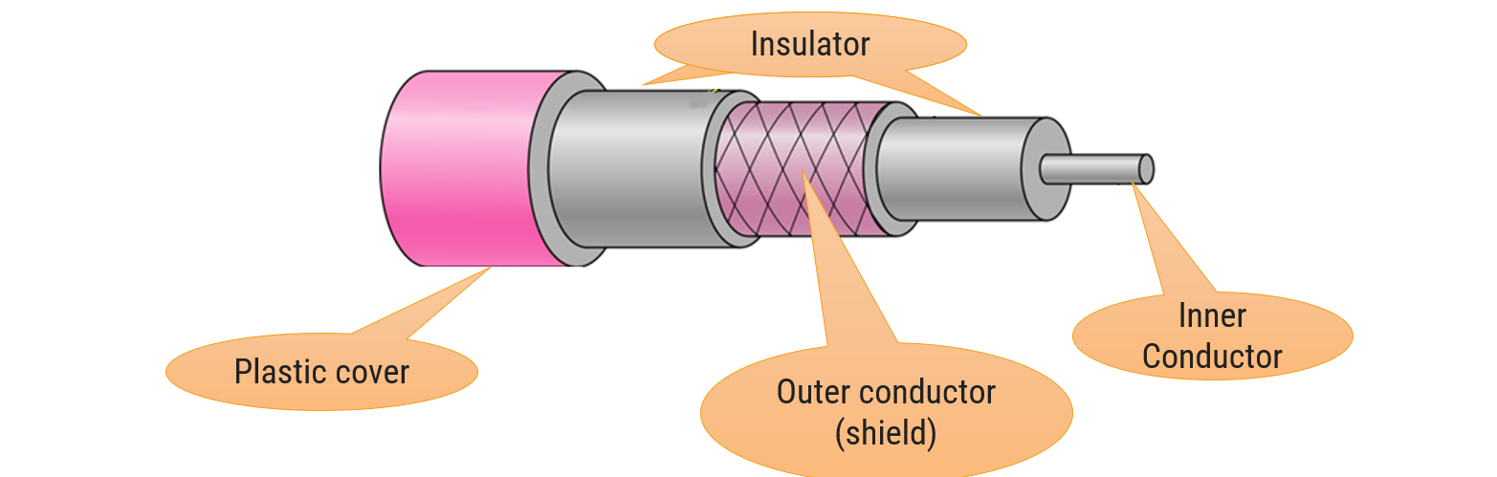

**c) Fiber Optic Cable:**

* **Construction:**
  + **Core:** Narrow strand of glass or plastic for transmitting light.
  + **Cladding:** Surrounding layer with a lower refractive index to enable totalinternalreflection.
  + **Jacket:** Protective plastic outer layer.
* **Working Principle:** Uses lightsignals for data transmission, relying on reflection inside the core.
* **Features:**
  + Provides very high bandwidth and long-distance transmission.
  + Immune to electromagnetic interference.
  + Lightweight, small size, and lowattenuation.
* **Advantages:**
  + Faster data transmission than copper cables.
  + Can carry data over longer distances.
  + Reliable and secure.
* **Usage:** Internet backbone, high-speed data centers, long-distance communication, enterprise networks.
* **Connector:** SC, ST, LC connectors.
* **Diagram:**

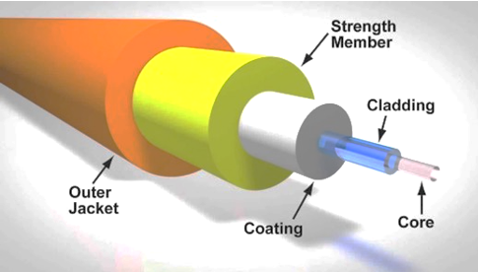

1. **Difference between guided and unguided media.**

| **Aspect** | **Guided Media** | **Unguided Media** |
| --- | --- | --- |
| Medium | Uses a physical path like cables or wires. | Transmits data through the air (no medium). |
| Examples | Twisted Pair, Coaxial Cable, Fiber Optic Cable. | Radio Waves, Microwaves, Infrared, Satellite. |
| Transmission Path | Fixed and well-defined. | Not fixed; data can spread in all directions. |
| Bandwidth | Higher bandwidth (especially fiber optic). | Lower bandwidth compared to guided media. |
| Data Security | More secure, as data travels inside a cable. | Less secure; signals can be intercepted easily. |
| Interference | Less susceptible to interference. | Highly susceptible to noise, interference, and obstacles. |
| Signal Attenuation | Lower (especially in fiber optic). | Higher; requires boosters/repeaters for long distances. |
| Cost | Generally higher due to cable and installation costs. | Lower; no physical installation required. |
| Mobility | Stationary; cannot move after installation. | Highly mobile (wireless communication). |
| Maintenance | Requires physical maintenance. | Easier to maintain; fewer physical parts. |
| Use Cases | LAN, wired broadband, data center. | Wi-Fi, cellular networks, satellite communication. |

## Give cross-wired cable and straight through cable diagram (Color Code wise).

1. Cross-wired Cable Diagram (Color Code)

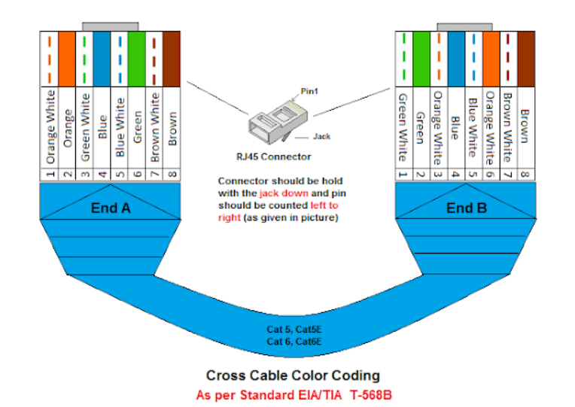

1. Straight Through Cable Diagram (Color Code)

